Automating Employee Data Import in ServiceNow

Team
Team Leader: Mohamed Asik B
Team Member: Bharathraj D
Team Member: Harieaswar M J
Team Member: Kathiravan K

Project Screenshots

Step Screenshot 1
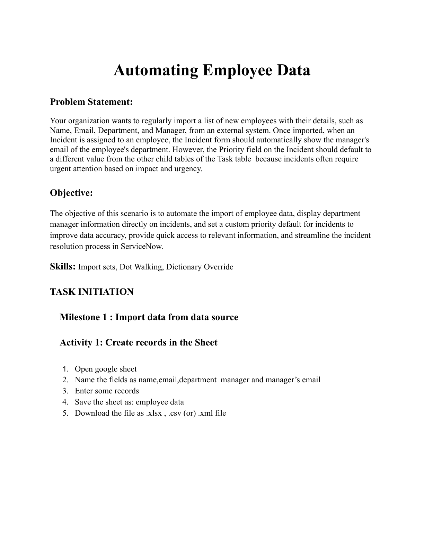

Step Screenshot 2
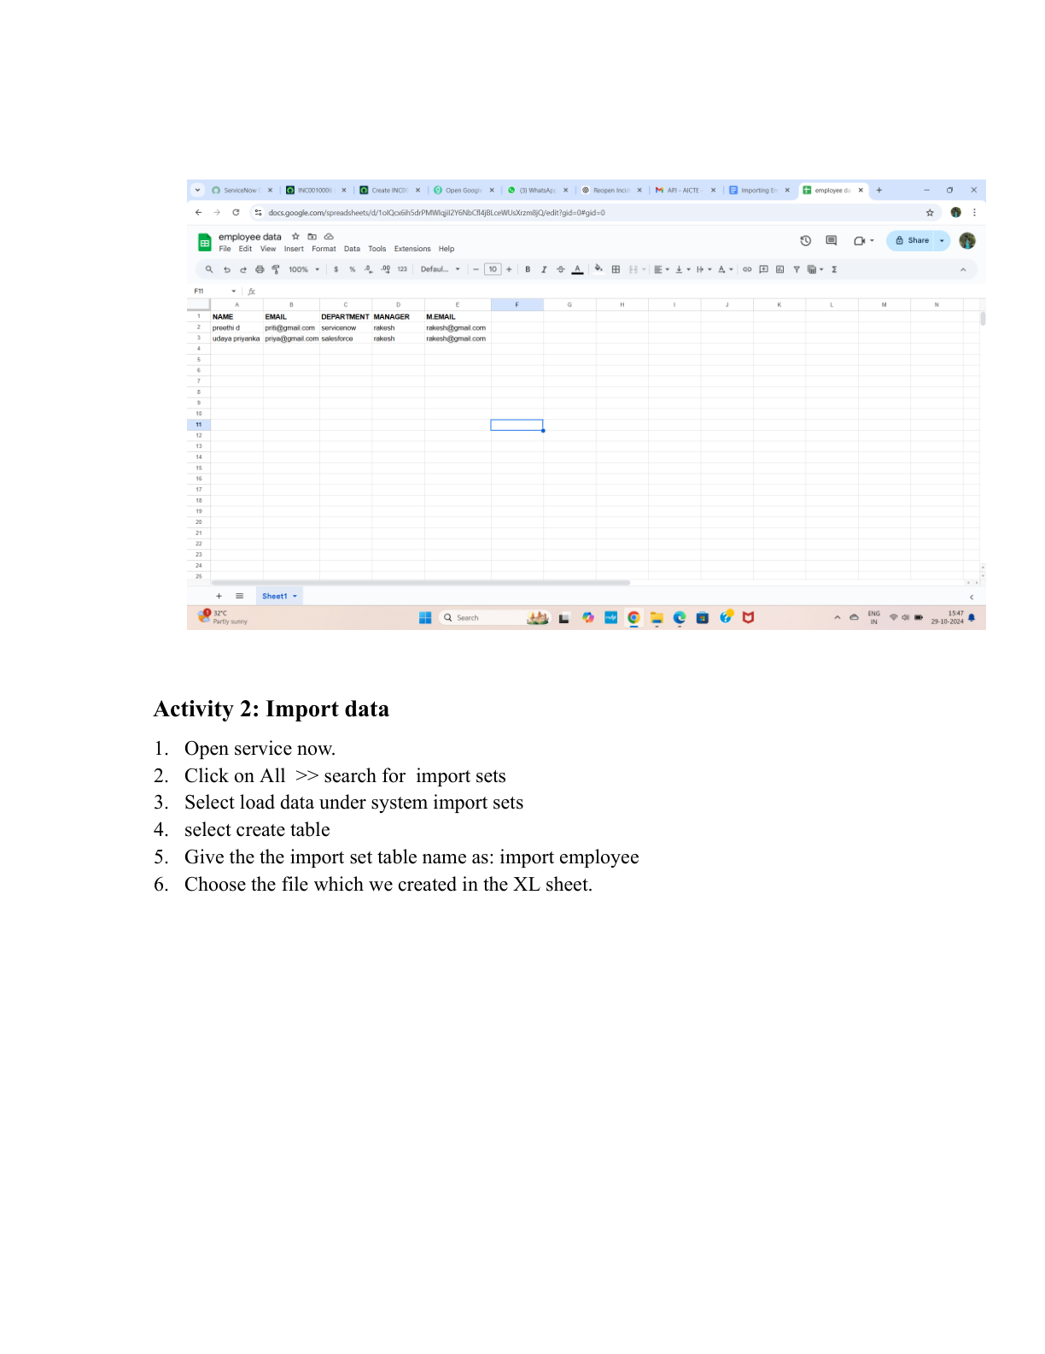

Step Screenshot 3
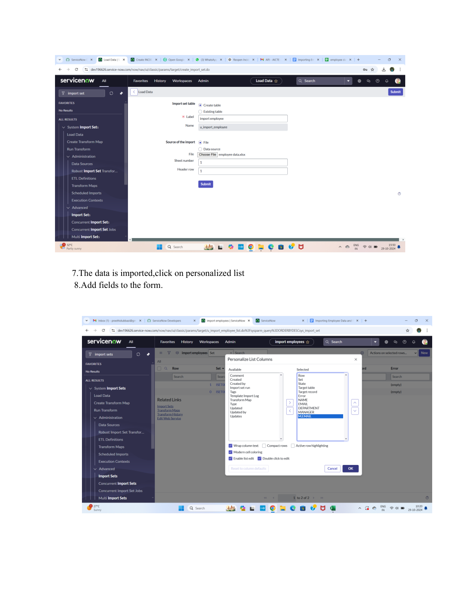

Step Screenshot 4
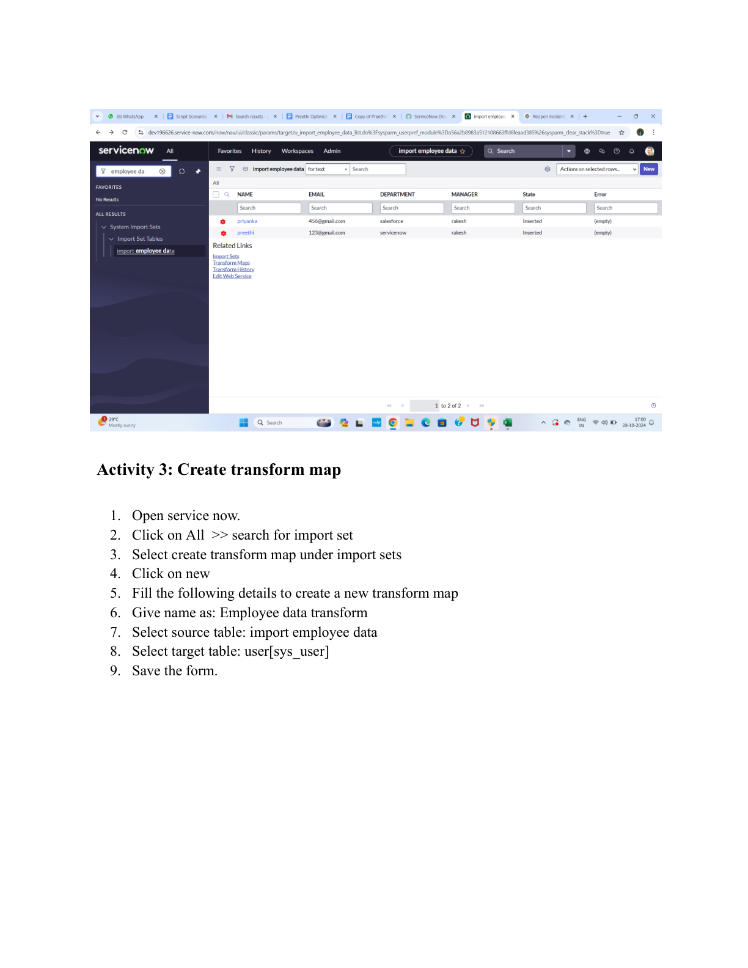

Step Screenshot 5
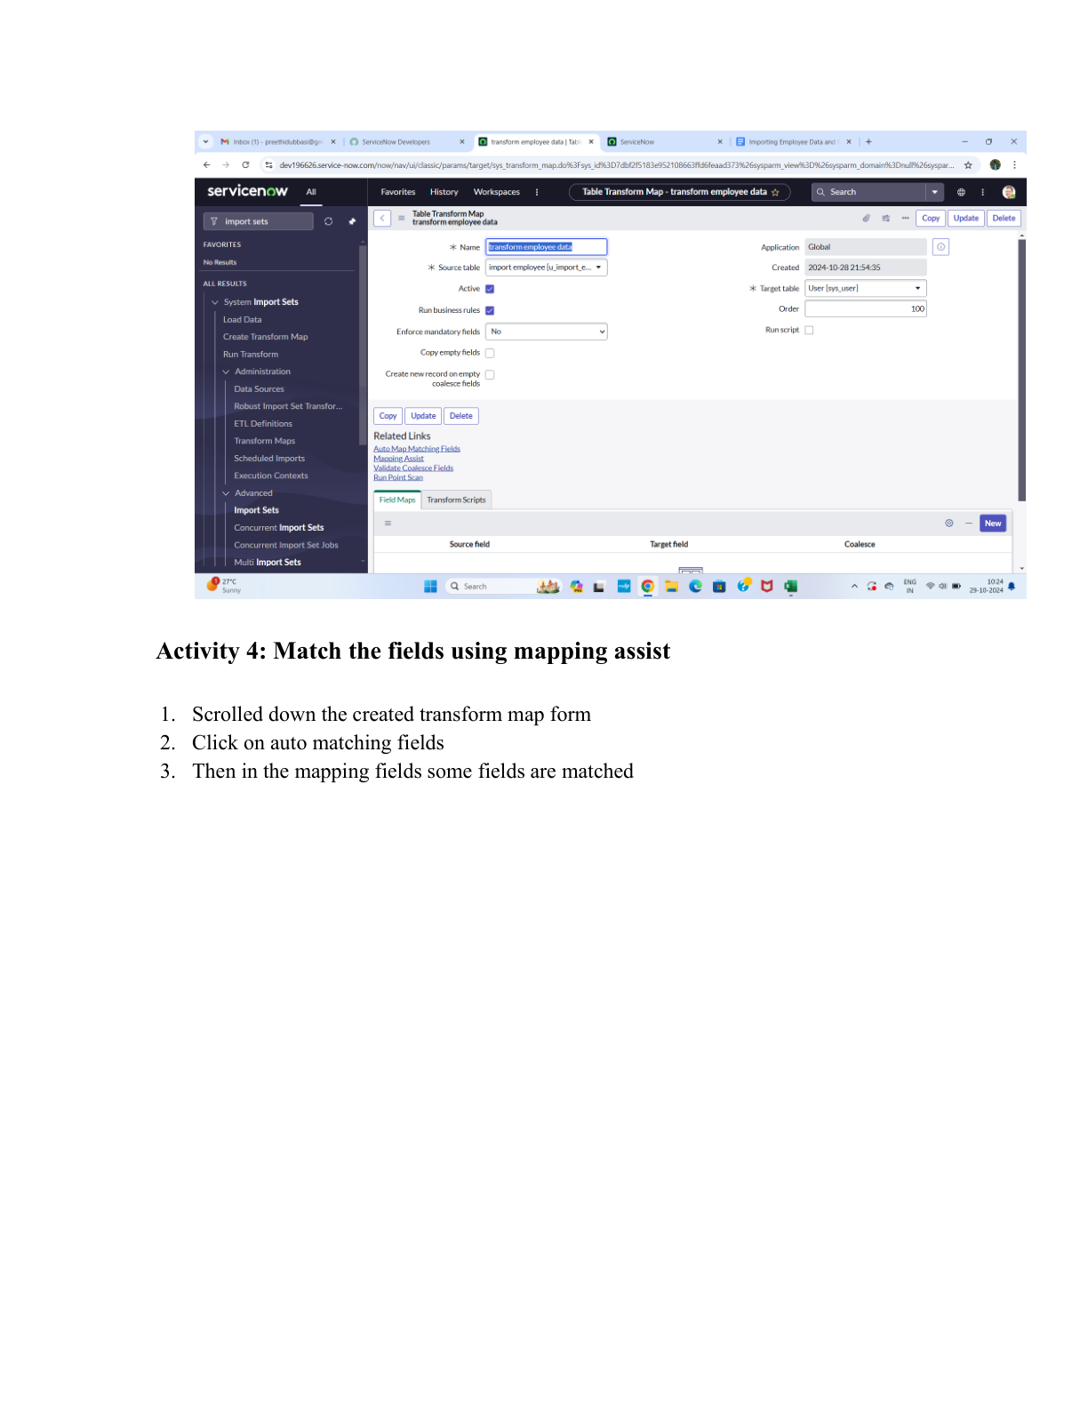

Step Screenshot 6
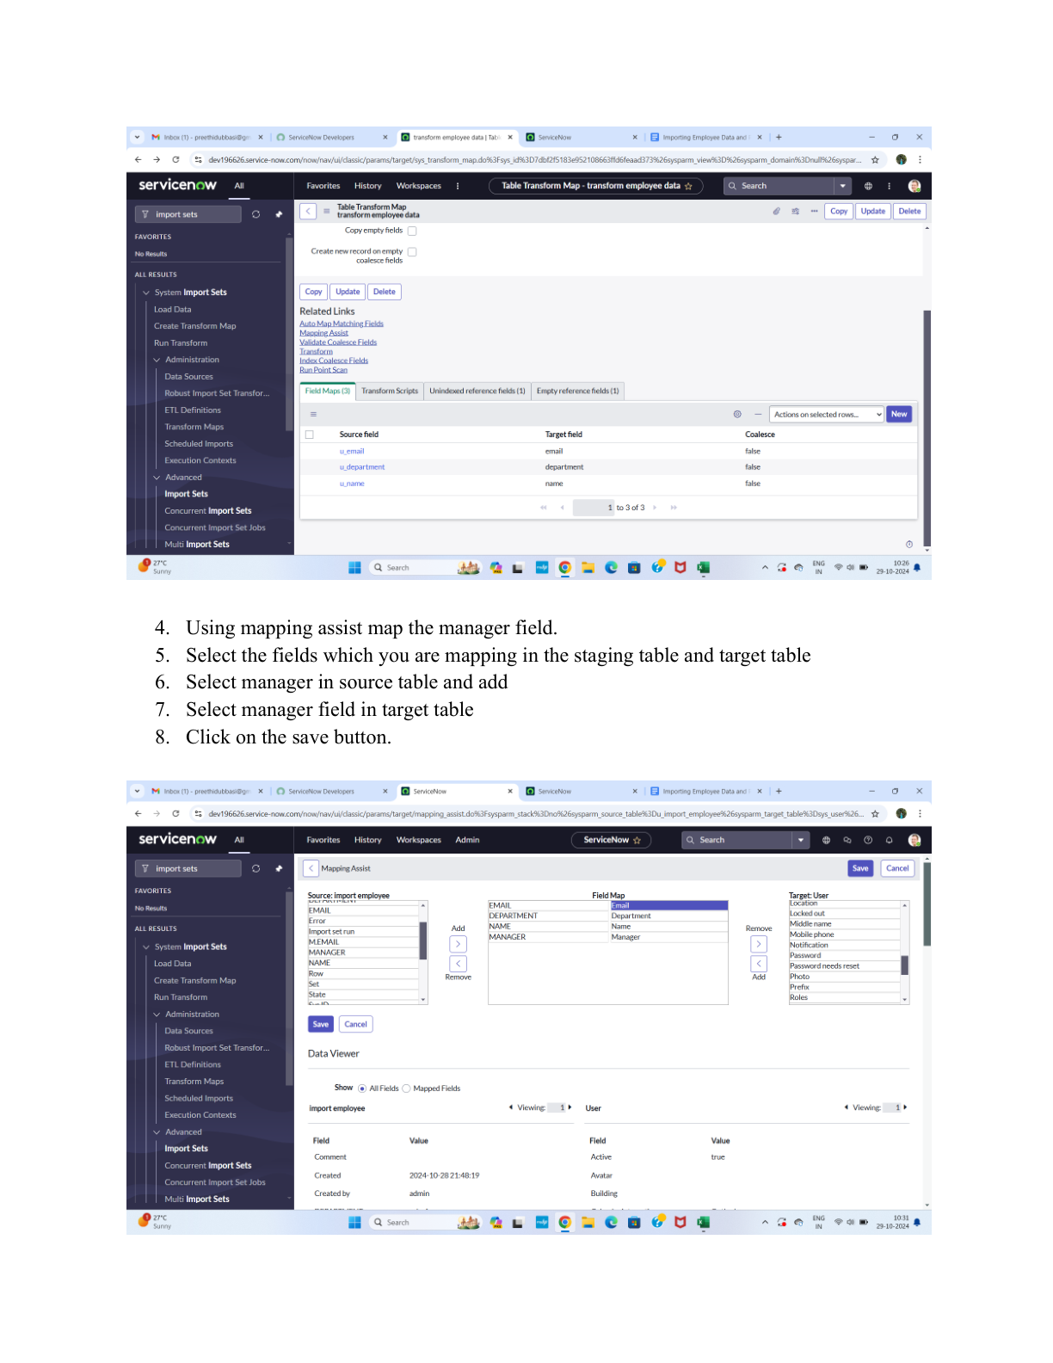

Step Screenshot 7
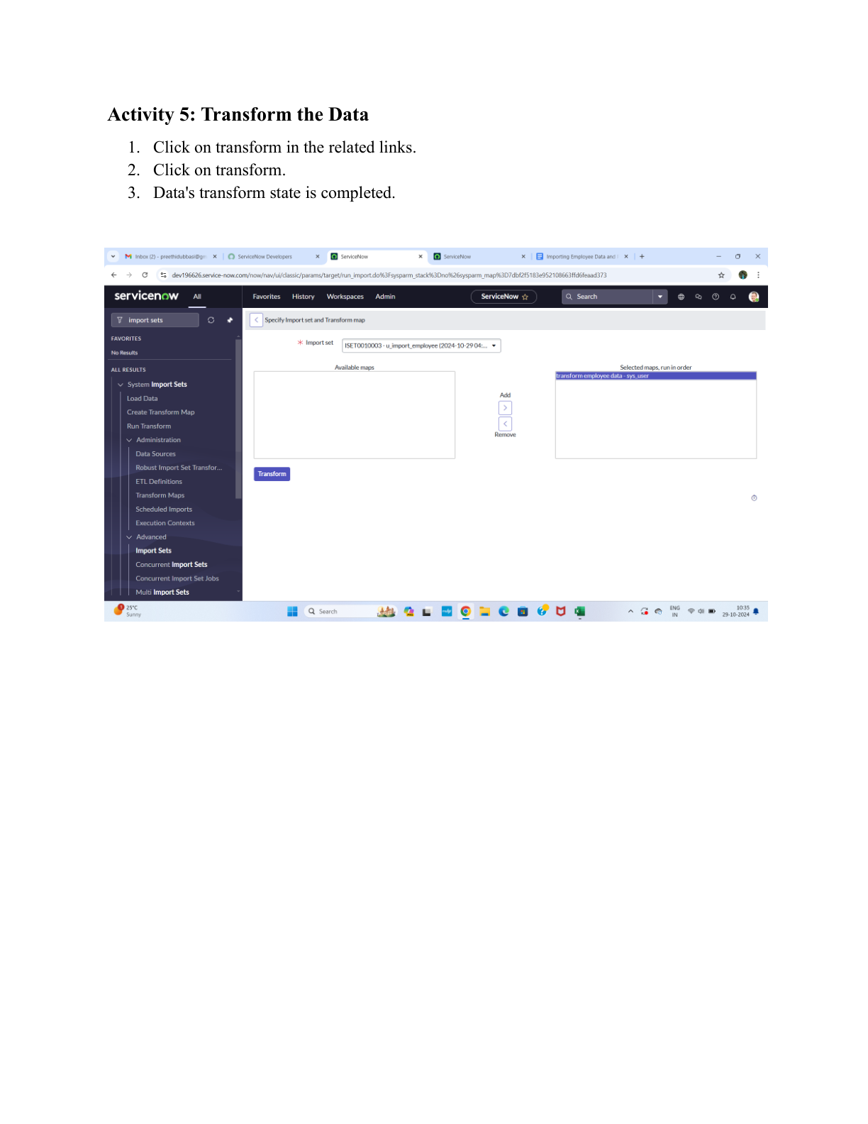

Step Screenshot 8
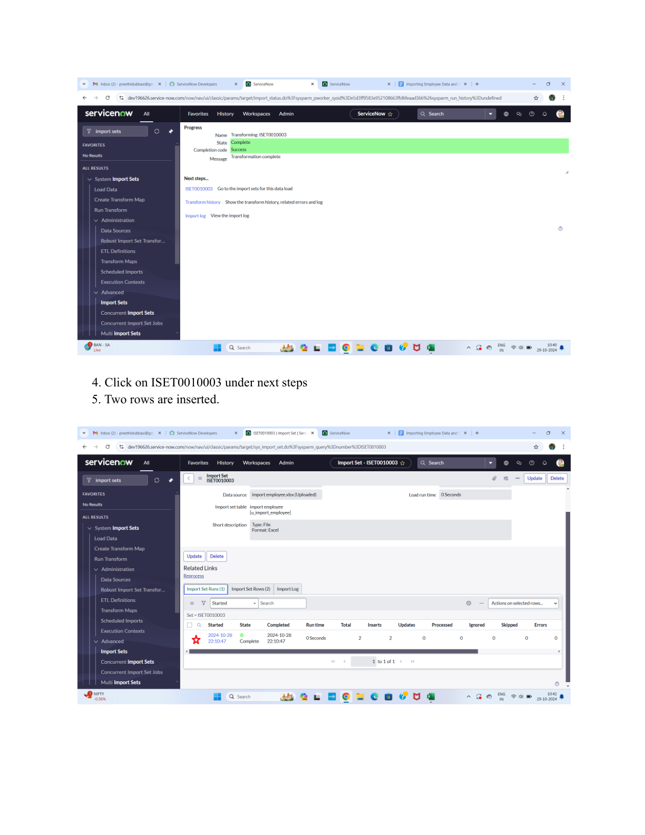

Step Screenshot 9
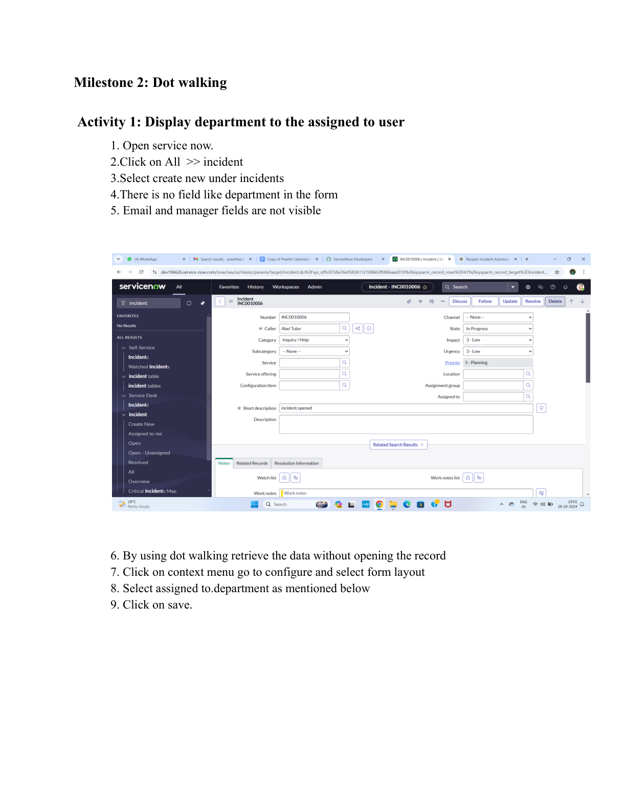

Step Screenshot 10
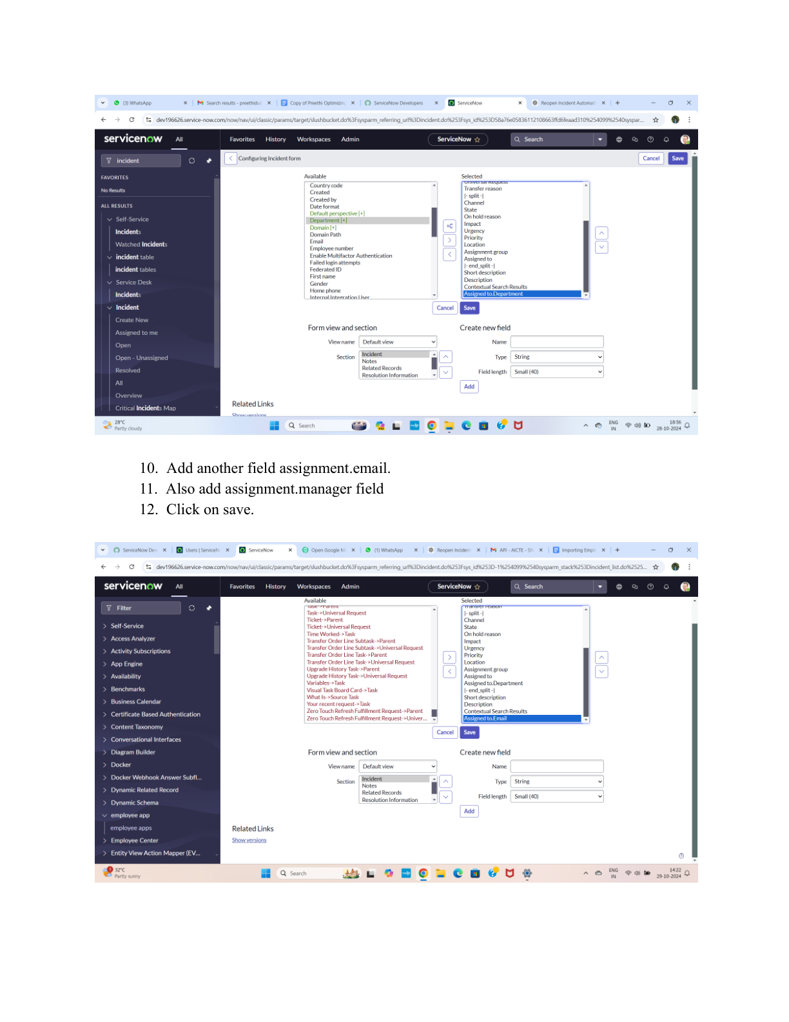

Step Screenshot 11
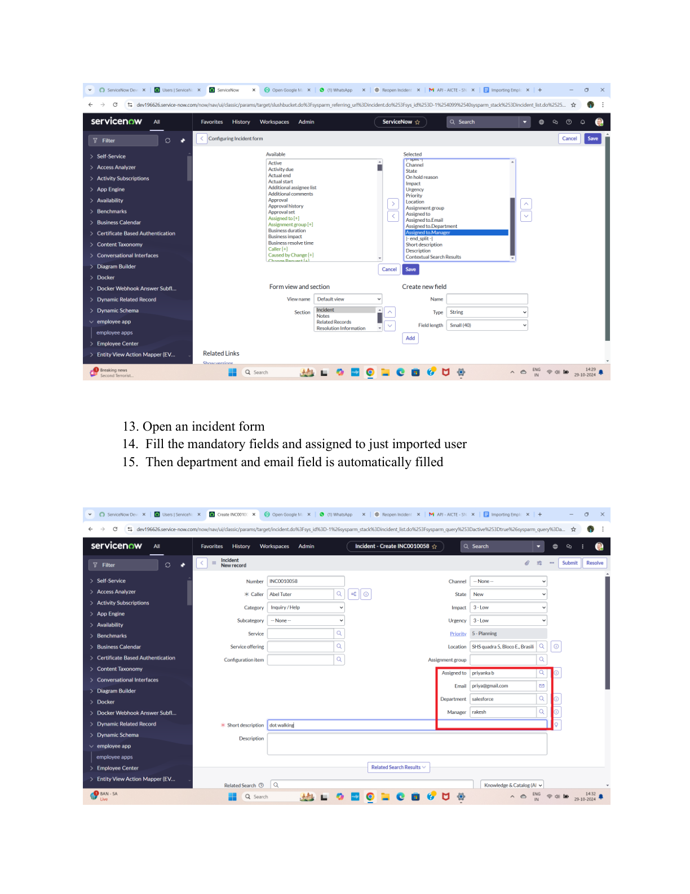

Step Screenshot 12
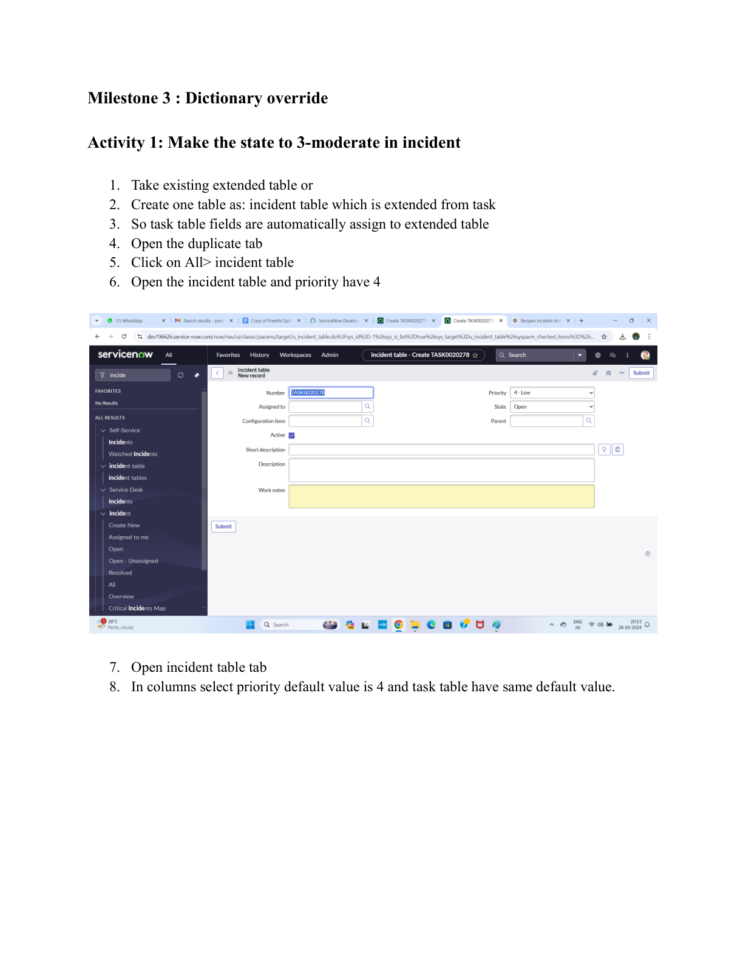

Step Screenshot 13
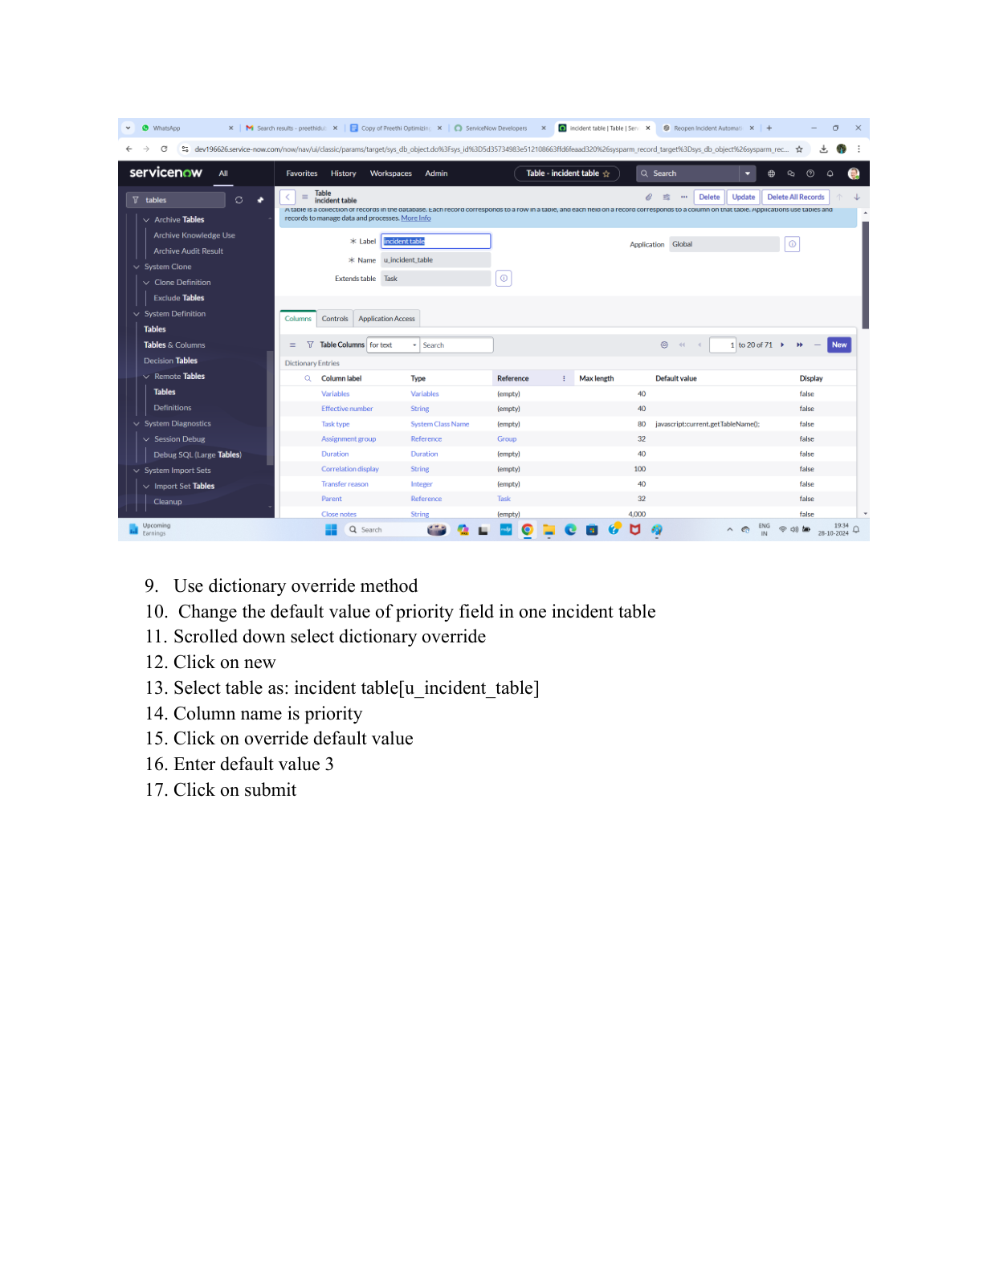

Step Screenshot 14
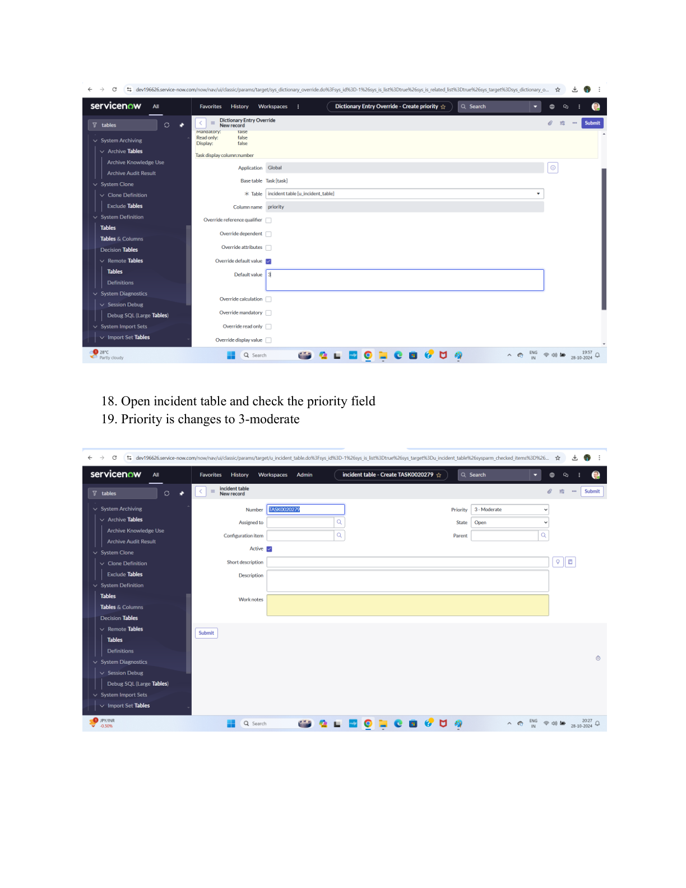

Step Screenshot 15


